Supplementary table: Distribution of study populations by duration of medication use categories.

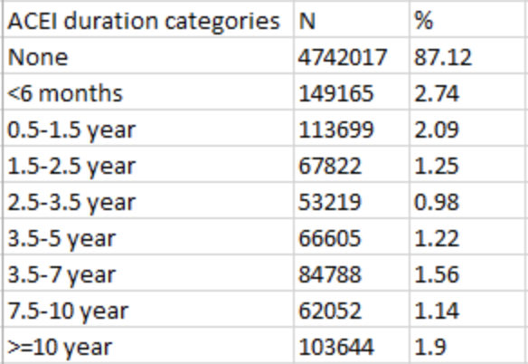

Supplementary table: definition of influenza

